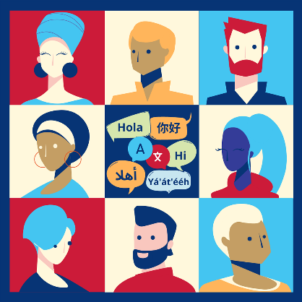
Planning for Culturally
Responsive Projects
Inputs
Who needs to be involved, and what resources will you need?
Activities  What do you need to do to create the outputs? What considerations will you make for plain language, translation, and cultural adaptation? | What or whom might you:  - Talk to  - Meet with  - Bring together  - Design  - Hear from  - Schedule  - Secure
Outputs
What products, tools, or events will you produce?
Outcomes
How do your outputs affect the people who experience them?
Impact
What impact do your outcomes have on the lives of children and families?

