Handout #1: North, South, East and West

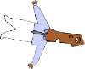Activity: Compass Points

Purpose:
- To explore various ways that individuals approach teamwork,
- To increase understanding of the strengths and limitations of each preference,
- To suggest ways to utilize these differences in team work.

Directions:
DECLARE ONE “direction” on the compass based on what you think best describes the way you work within a group.

NORTH: Acts right away, let’s just do it,
likes to try things and plunge in.

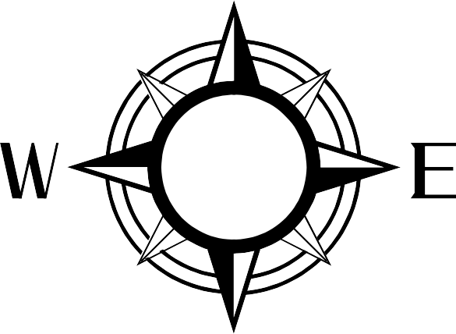WEST: Pays attention to EAST: Speculating,
detail, likes to know who, looks at the big picture,
what, where, when, the possibilities before
and why before acting.
acting.

SOUTH: Caring, likes to know that everyone’s feelings have been taken into consideration,
that their voices have been heard, before acting.

DECLARE your “direction”:

Slide 125A

Handout #1: North, South, East and West

Work Style Questions:
Record the group’s answers here or on your large sheet of paper.

- What are the strengths of our work style? (list at least 4)

- What are the limitations of our work style? (list at least 4)

- What work style do we find the most difficult to work with? Why?

- What do others need to know about us that will make our work together more successful?

