District Aggregated Data:

Disaggregate Data:

Slide 111A
Aggregated Data: The graph below shows the percentage of ALL students in a given school year who scored either proficient or advanced on the Wisconsin Student Assessment System (WSAS) test. The test taken includes the Wisconsin Knowledge and Concepts Exam (WKCE) with or without accommodations and the Wisconsin Alternative Assessment for Students with Disabilities (WAA-SwD). Statewide results are shown in Blue while district results are shown in gold. The data reflects the results of ALL students which means every student in grades 3rd, 4th, 5th, 6th, 7th, 8th, and 10th. 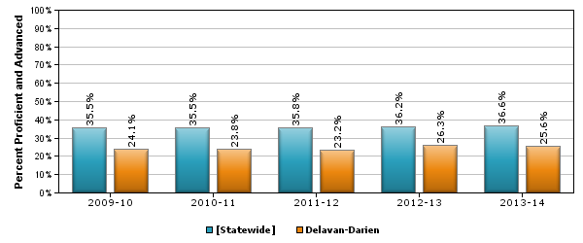
Proficient/Advanced by Year
Statewide School District

Percentage of Students Scoring Proficient or Advanced in Reading
 | 2009-10 | 2010-11 | 2011-12 | 2012-13 | 2013-14
State | 35.5% | 35.5% | 35.8% | 36.2% | 36.6%
School District | 24.1% | 23.8% | 23.2% | 26.3% | 25.6%
Question:
What observations can be made about students in this school district based on the information in this bar graph and the data table?

Disaggregated Data: Percentage of Students Scoring Proficient or Advanced in Reading in 2012-2013 by Grade Level.During the 2012-2013 school year, 36.2% of students statewide scored Proficient or Advanced on the WSAS. 26.3% of district students scored Proficient or Advanced. The graph below shows the 2012-2013 data by Grade Level. Statewide results are shown in Blue while district results are shown in gold.
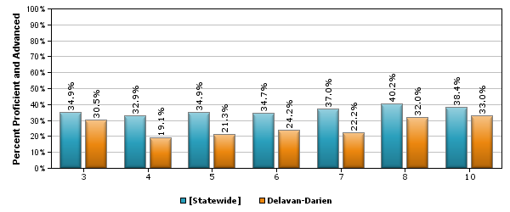
Performance by Grade Level
Statewide School District

Percentage of Students Scoring Proficient or Advanced in Reading in 2012-2013 by Grade Level:
 | 3rd grade | 4th grade | 5th grade | 6th grade | 7th grade | 8th grade | 10th grade
State | 34.9% | 32.9% | 34.9% | 34.7% | 36.6% | 40.2% | 38.4%
School District | 30.5% | 19.1% | 21.3% | 24.2% | 25.6% | 32.0% | 33.0%
Question:
What observations can be made about students in this school district based on the information in this bar graph and the data table?
How do statewide data compare to district?
How do grades compare to each other?

Disaggregated Data:District data comparing Students without disabilities in Blue compared to students with disabilities in Gold. This is trend data from 2009-2010 to 2013-2014.
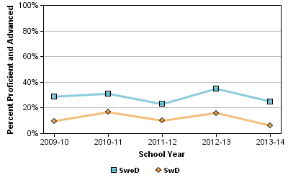
What does this line graph tell you about students with disabilities?

Disaggregated Data: This graph displays data comparing Students without disabilities (SwoD) and students with disabilities (SwD). Data showing Statewide results and the results from three district elementary schools. This is data from the 2012-2013 school year.
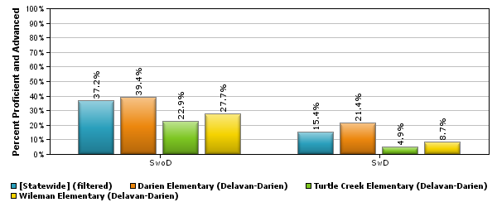
Elementary School Comparison (4 schools):
School A School B School C School D

Disaggregated Data: 2012-2013 Reading Proficient/Advanced Percentages in Reading comparing Students Not Economically Disadvantaged to Economically Disadvantaged Students.
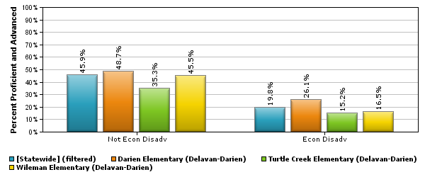
Elementary School Comparison (4 schools):
School A School B School C School D

Disaggregated Data: Trend data on Reading Proficient/Advanced Percentages is shown in this bar graph from 2009-2010 school year to 2013-2014. Data is disaggregated by elementary school and compared to statewide data.
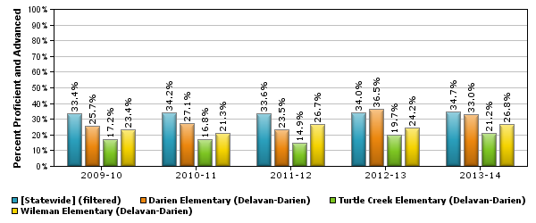
Elementary School Comparison (4 schools):
School A School B School C School D

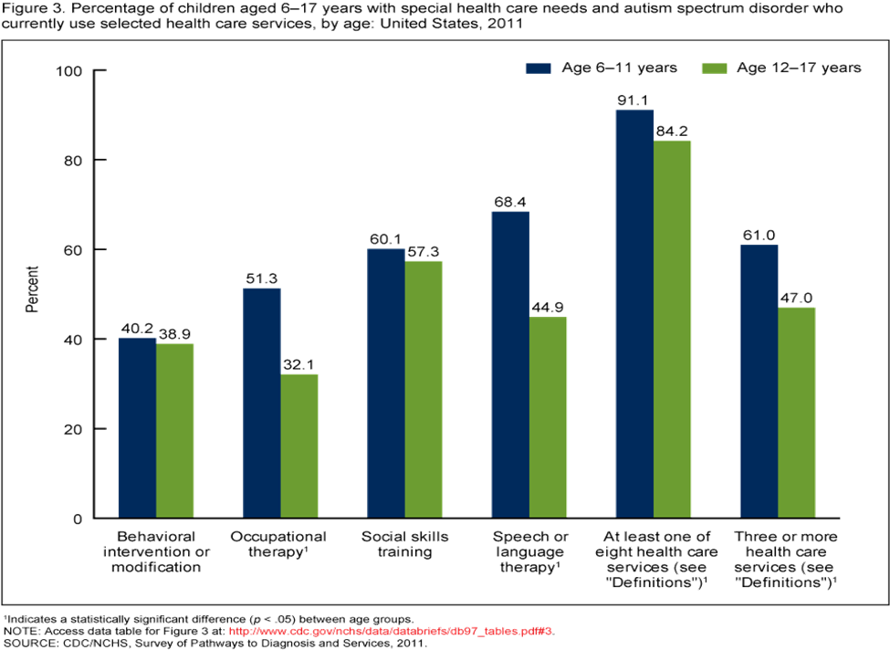

What goal , question or problem did you start out with?
This line graph displays an example of the percentage of children aged 6-17 in the United States in 2011 with special health care needs and autism spectrum disorder who currently use an array of health care services.The CDC now needs to break down the national data to provide information to each state. This would help each state to see where they can improved therapeutic service delivery to children.

Collecting Data Chart
Describe the data used
- Demographics including, status of therapy or intervention
- How the health centers provide services
- Percentage of individuals receiving services
Where did find the data
CDC/NCHS Survey of Pathways to Diagnosis and Services report
The check boxes should be
Staff
Parent

