Resources:
Data Example handouts
Poster paper
Markers

Approximate Time:
15 minutes

Purpose:
The purpose of this activity is to give participants an opportunity to apply what they’ve learned in
the Understanding Data section. Participants will look at a source of data in a variety of formats,
analyze the data and answer questions about the data.

Directions:
- Divide participants into groups of 3-5 people.
- Provide each group one of the Data Example Scenarios.
- Have each group answer the questions at the bottom of each scenario.
- Additional questions to consider are as follows:
  - What is the range of values?
  - Does the data have a direct or indirect relationship?
  - Are there positive or negative slopes?
  - Where was there the most change or growth?
  - Where was there the least change or growth?
  - To support the data’s claim, what else could you do?
  - What is the Mean of the data you are looking at?
  - What is the Median of the data you are looking at?
  - What is the Mode of the data you are looking at?
  - What is the Range of the data you are looking at?
  - What story does the data tell you?
- Allow groups 15 minutes to complete the small group work.
- Allow some sharing out regarding what they learned, noticed, and experienced.

Slide 98

Data Example #1 -
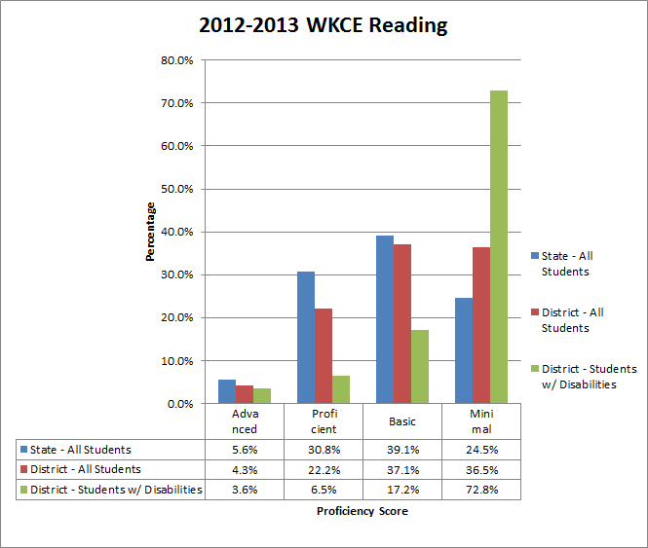
Questions to consider:
a. What does the horizontal, x-axis, measure? What does vertical, y-axis, measure?
b. What data are you looking at?
c. What do you notice about the data? Differences or similarities?

Data Example #2 -
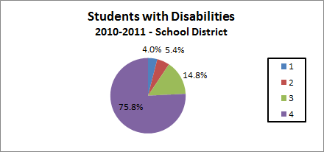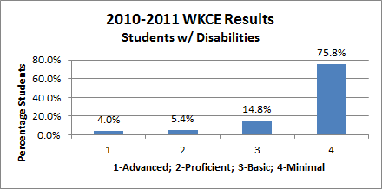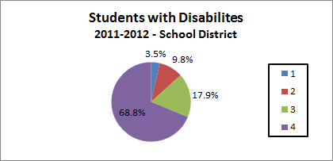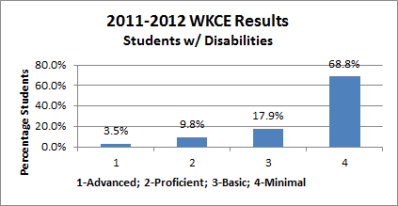
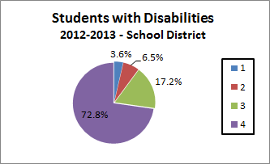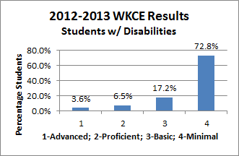
Questions to consider:
a. What does each pie chart measure?
b. In the bar graphs on the left, what does the horizontal, x-axis, measure? What does vertical, y-axis, measure?
c. What data are you looking at?
d. What do you notice about the data? Differences or similarities?

Data Example #3 -
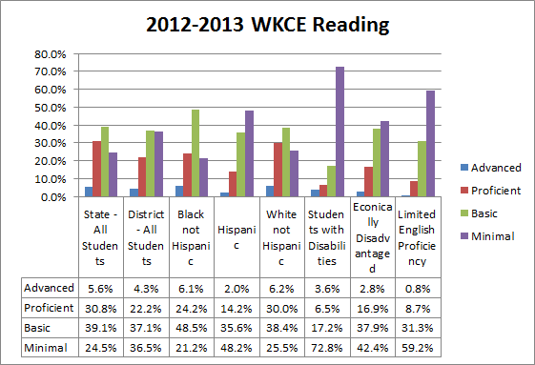

Questions to consider:
a. What does the horizontal, x-axis, measure? What does vertical, y-axis, measure?
b. What data are you looking at?
c. What do you notice about the data? Differences or similarities?

Data Example #4 -
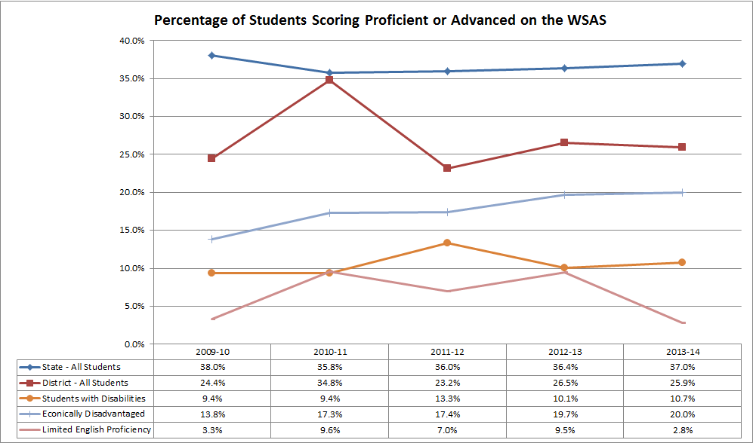

Questions to consider:
a. What does the horizontal, x-axis, measure? What does vertical, y-axis, measure?
b. What data are you looking at?
c. What do you notice about the data? Differences or similarities?
d. What trends or patterns does the data show?

Data Example #5 -
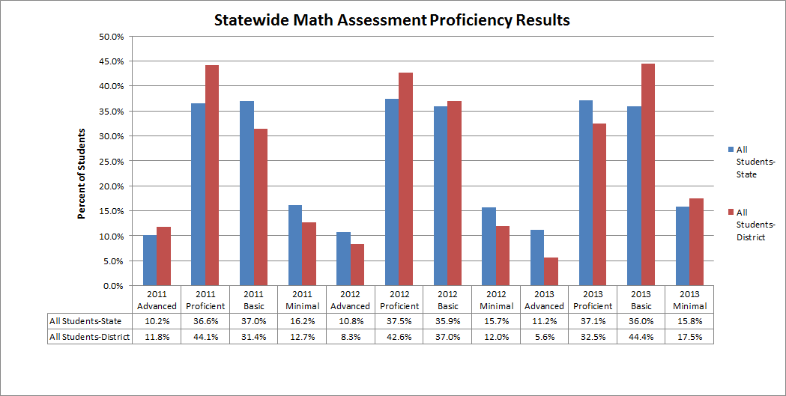
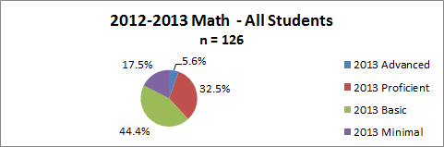

Questions to consider:
a. What does the horizontal, x-axis, measure? What does vertical, y-axis, measure?
b. What does the pie chart measure?
b. What data are you looking at?
c. What do you notice about the data? Differences or similarities?
d. What trends or patterns does the data show?

Data Example #6 -

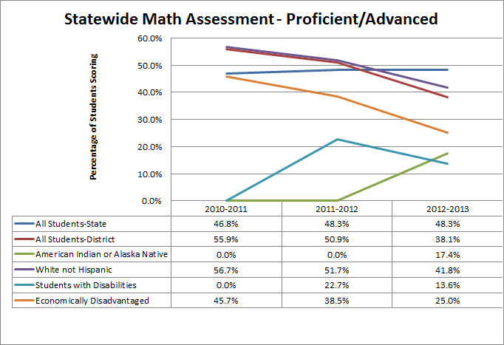

Questions to consider:
a. What does the horizontal, x-axis, measure? What does vertical, y-axis, measure?
b. What data are you looking at?
c. What do you notice about the data? Differences or similarities?

Data Example #7 -
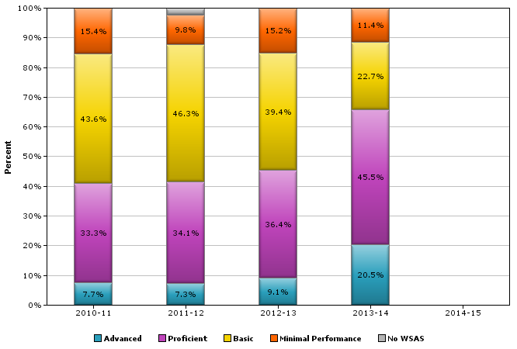
School Year | Proficiency Level | Percent of Group
2010-2011 | Minimal Performance | 12.0%
2010-2011 | Basic | 39.1%
2010-2011 | Proficient | 40.8%
2010-2011 | Advanced | 7.3%
2010-2011 | No WSAS | 0.9%
2011-2012 | Minimal Performance | 14.0%
2011-2012 | Basic | 38.4%
2011-2012 | Proficient | 38.8%
2011-2012 | Advanced | 7.0%
2011-2012 | No WSAS | 1.7%
2012-2013 | Minimal Performance | 16.5%
2012-2013 | Basic | 35.2%
2012-2013 | Proficient | 42.7%
2012-2013 | Advanced | 5.2%
2012-2013 | No WSAS | .04%
2013-2014 | Minimal Performance | 12.2%
2013-2014 | Basic | 35.3%
2013-2014 | Proficient | 43.9%
2013-2014 | Advanced | 8.6%
2013-2014 | No WSAS | 0.0%
Questions to consider:
a. What does the horizontal, x-axis, measure? What does vertical, y-axis, measure?
b. What data are you looking at?
c. What do you notice about the data? Differences or similarities?
d. What trends or patterns does the data show?

Data Example #8 -

