Data Example #1 -
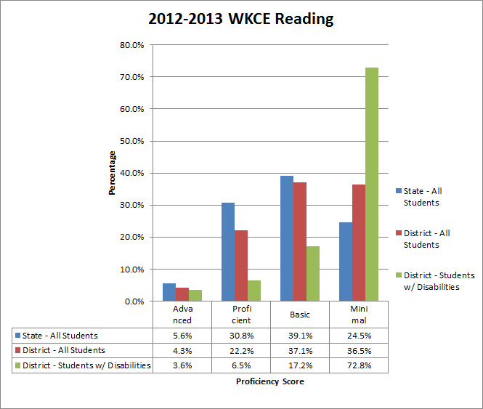
Questions to consider:
a. What does the horizontal, x-axis, measure? What does vertical, y-axis, measure?
b. What data are you looking at?
c. What do you notice about the data? Differences or similarities?

Data Example #2 -
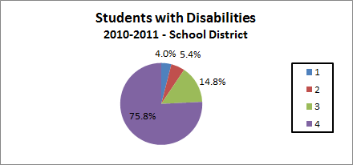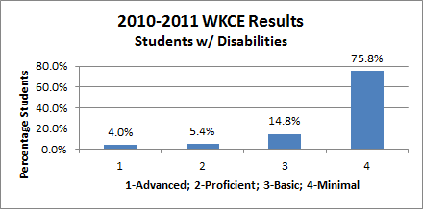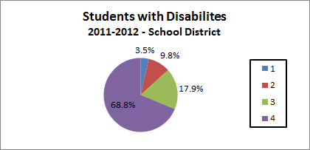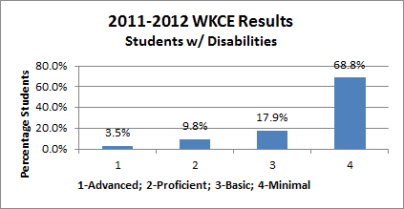
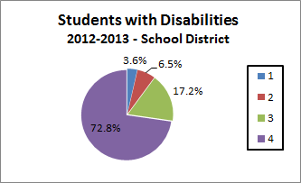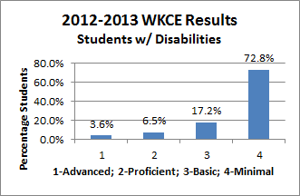
Questions to consider:
a. What does each pie chart measure?
b. In the bar graphs on the left, what does the horizontal, x-axis, measure? What does vertical, y-axis, measure?
c. What data are you looking at?
d. What do you notice about the data? Differences or similarities?

Data Example #3 -
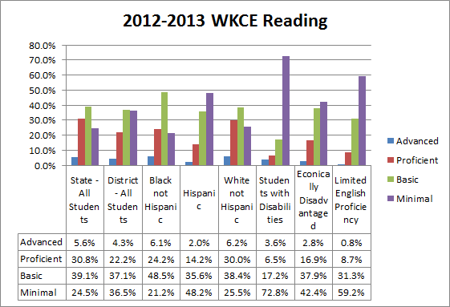

Questions to consider:
a. What does the horizontal, x-axis, measure? What does vertical, y-axis, measure?
b. What data are you looking at?
c. What do you notice about the data? Differences or similarities?

Data Example #4 -
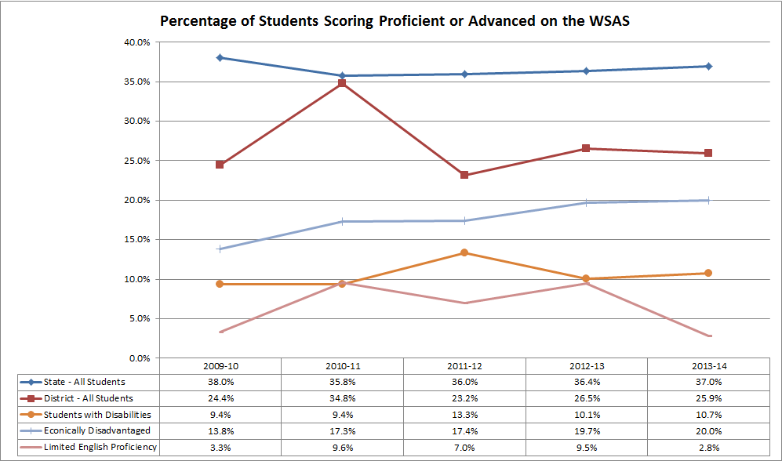

Questions to consider:
a. What does the horizontal, x-axis, measure? What does vertical, y-axis, measure?
b. What data are you looking at?
c. What do you notice about the data? Differences or similarities?
d. What trends or patterns does the data show?

Data Example #5 -
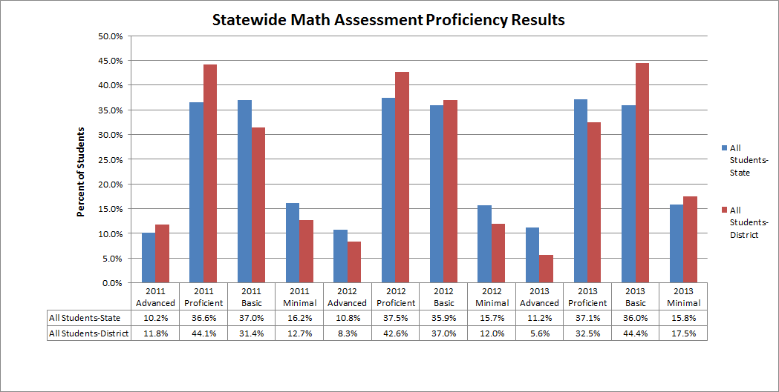
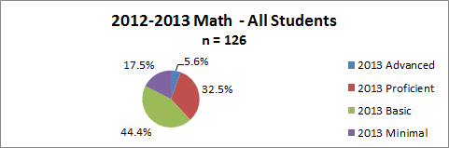

Questions to consider:
a. What does the horizontal, x-axis, measure? What does vertical, y-axis, measure?
b. What does the pie chart measure?
b. What data are you looking at?
c. What do you notice about the data? Differences or similarities?
d. What trends or patterns does the data show?

Data Example #6 -

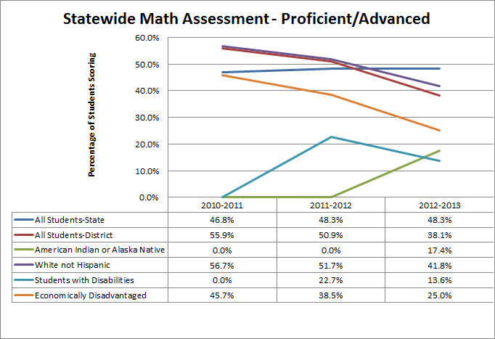

Questions to consider:
a. What does the horizontal, x-axis, measure? What does vertical, y-axis, measure?
b. What data are you looking at?
c. What do you notice about the data? Differences or similarities?

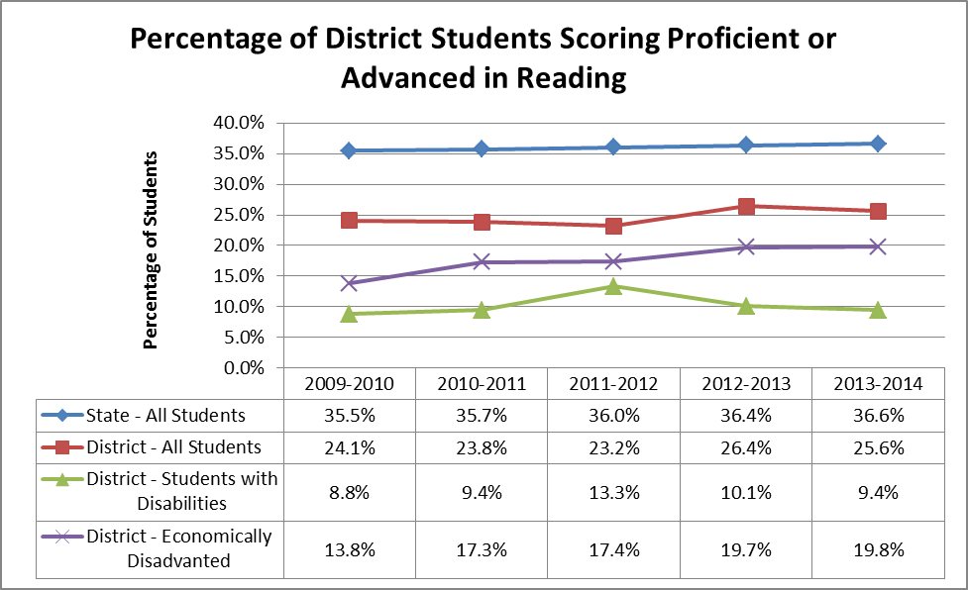
Porcentaje de estudiantes con puntuación proficiente o avanzado en lectura a nivel de distrito
Porcentaje de estudiantes
Estado - Todos los estudiantes
Distrito -Todos los estudiantes
Distrito - Estudiantes con discapacidades
Distrito - Estudiantes con discapacidades

Use el gráfico de líneas y la hoja de cálculo anteriores para responder a las preguntas.
¿Qué grupo o grupos de estudiantes están mejorando? ____________________________________
¿Qué grupo o grupos de estudiantes no han mostrado cambio alguno? _________________________
¿Qué nota usted con respecto a los datos en el tiempo? ___________________________________
Basándose en los datos, ¿qué preguntas tiene? _______________________________________

Use el gráfico de líneas y la hoja de cálculo anteriores para responder a las preguntas.
¿Qué grupo o grupos de estudiantes están mejorando? ____________________________________
¿Qué grupo o grupos de estudiantes no han mostrado cambio alguno? _________________________
¿Qué nota usted con respecto a los datos en el tiempo? ___________________________________
Basándose en los datos, ¿qué preguntas tiene? _______________________________________

Use the line graph and spreadsheet above to answer the questions.
Which group(s) of students are improving? ____________________________________________
Which group(s) of students are staying the same? _____________________________________
What do you notice about the data over time? _______________________________________
What questions do you have based on the data? ______________________________________

