Activity | Hours spent/week | Percentage of Week
Working - job | 40 | 23.81%
Caring for the Home/Laundry | 12 | 7.14%
Driving | 8 | 4.76%
Sleeping | 49 | 29.17%
Exercising | 5 | 2.98%
Volunteering | 4 | 2.38%
Taking care of Family | 30 | 17.86%
Time for self | 3 | 1.79%
Shopping/Errands | 6 | 3.57%
Church/religious activities | 3 | 1.79%
Hours left | 8 | 4.76%
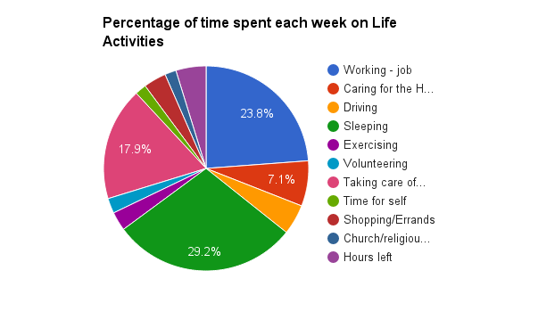
Do I have time in my daily or weekly schedule to commit to a decision-making group?
What might need to change for me to be able to participate?
SLIDE 022A

