LEADING BY CONVENING: THE PARTNERSHIP WAY
An Introduction

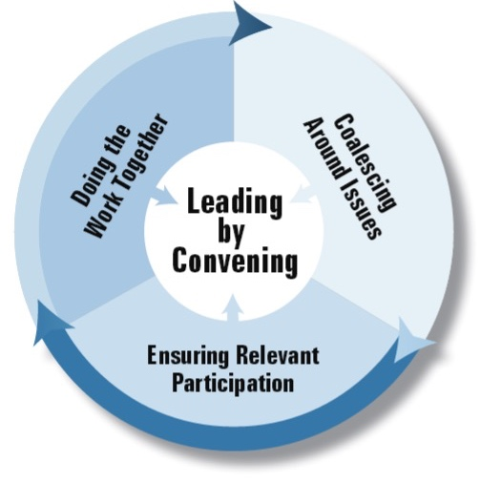
What Is Leading by Convening?
Leading by Convening is an overarching idea, a guiding framework and a new discipline for leaders at every level. It is a leadership model that bridges policy and practice to approach work differently, a shared leadership model that honors what decision makers, practitioners and consumers know and are willing to do on an issue. It’s a philosophy that respects both authority and influence. Leading by Convening: The Partnership Way is actually a set of training, tools, and resources for state, regional and local leaders (“conveners”) to use in their work to engage stakeholders in systemic improvement initiatives.

Why do we need Leading by Convening?
When we think about leadership, we think of two different styles. What we most often historically experience is top-down leadership, a more formal approach, grounded in authority and formal channels of influence. And what we see evolving and becoming more prevalent is a bottom-up style, which is more informal and involves those who are impacted by the decisions being made. Leading by Convening is a hybrid of these two leadership designs. It is about embracing the value of bringing groups with authority and groups with influence together for shared decision-making. This style supports authentic engagement; it is leading by convening.

Leading by Convening is intended to equip government and professional agencies with the knowledge, skills, and tools to more effectively and meaningfully engage diverse parents and other stakeholders at all levels. It is the training that will help prepare them to be “more ready” to create a welcome the contributions of diverse family and youth leaders who want to have a more meaningful and impactful voice in quality improvement.

What are the basics of the Leading by Convening Toolkit?
The Leading by Convening toolkit helps organizational leaders recognize the balance between top-down and bottom-up leadership. It is designed to facilitate the understanding of the difference between technical skills and the adaptive/personal/relational skills needed to engage diverse stakeholders in quality improvement.

Its whole framework is designed around habits of interaction, elements of interaction and depth of interaction. Built into all aspects of the training is the balance of the technical and adaptive aspects that should be considered. It also considers operational elements. Operational elements are the decisions that a group makes after considering both the technical and adaptive sides of an issue. They move a decision-making group forward.

A way to envision the entire framework is outlined below. The habits, elements and depths of interaction can help change our approach to decision-making.
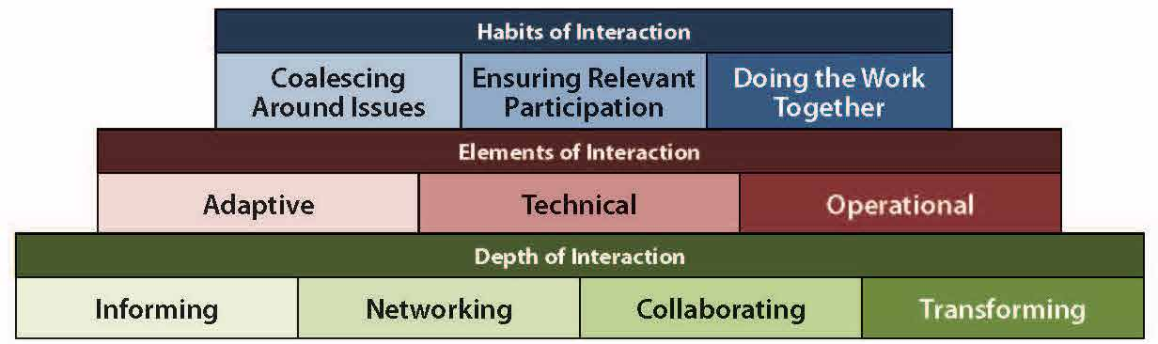
The depth of interactions may be at the heart of Leading by Convening. Here is where the real work becomes transparent as state systems actively engage stakeholders deeply and with meaning. This depth is measured using these four distinct categories:
• Informing – Sharing or disseminating information with others who care about the issue.
• Networking – Asking others what they think about this issue and listening to what they say.
• Collaborating – Engaging people in trying to do something of value and working together around the issue.
• Transforming – Doing things The Partnership Way (leading by convening, cross-stakeholder engagement, shared leadership, consensus building).

How is Leading by Convening being used?
The Leading by Convening curricula and tools were developed with user participation and input, designed with adult learning principles in mind, and tested with multiple diverse audiences – including state and local government agencies and family-led organizations - in states and localities across the country. Two current significant uses include:
- The US Department of Education has funded the National Center for Systemic Improvement (NCSI) to provide technical assistance to state early intervention and special education systems to improve outcomes for infants, toddlers, children and youth via State Systemic Improvement Plans. NCSI is using Leading by Convening as a core strategy in their work with states.
- The US Department of Health and Human Services’ Maternal and Child Health Bureau has funded the National Center for Family Professional Partnerships (NCFPP) to provide technical assistance to state Maternal-Child Health (MCH) programs and Family to Family Health Information Centers to help them improve child and family outcomes. The NCFPP is using Leading by Convening as its core strategy to help state agencies and other MCH-funded entities work more closely with diverse families.

You can find out more about Leading by Convening at www.ideapartnership.org/building-connections/the-partnership-way.html or https://ncsi-library.wested.org/resources/171.

